Production of virus free Sweetpotato planting materials using horticultural fleece
Paul Omuse Obusuru¹., Ochodho¹. J.O1., Schulte-Geldermann, Elmar ². Jan Low ^{2.},Agili Sammy²,Ndolo Philip³
¹. Moi University, School of Agricultural sciences
² International Potato Center (CIP), SSA regional office. Nairobi, Kenya
³. Kenya Agricultural Research Insitute, Kakamega, Kenya

Abstract: Sweetpotato (Ipomea batatas) is one of the most important staple crops in densely populated parts of Eastern Africa and is quickly becoming an important supplementary staple in the southern part of the continent (Silver et al, 2004). It is vital to small scale farmers with limited land, labor and capital. One of the major yield limiting factors in sweetpotato production are lack of clean planting material owing to infection of Sweetpotato virus diseases (SPVD)
Therefore there is a need to provide farmers with better technologies for rapidly multiplying clean planting materials and maintaining a clean stock for a long period on-farm without compromising on the quality
An experiment was set at Kakamega Agriculture research station (Altitude 1585m, 0 16’N and 34 45 E, annual precipitation 1995mm, annual evaporation 1770 mm), in Kenya from June 2009 to July 2010. The soil is deep fertile basaltic loam fertile that are well drained Three varieties of sweet potato free from virus but susceptible to SPVD obtained from CIP Nairobi, Kenya were evaluated against three methods of control –exposed, Fleece-cover and Fleece-tunnel.
The experiment was laid out as factorial experiment with a randomized complete block design with 3 replications. Each replication acted as a block with each block having 9 plots. Sizes of plot were 2mx5m with plant population of 500. Spacing was 10cm between plants and 20 cm between lines with each line having 25 plants. After 5 months data was taken on vine vigor, aphid and white fly population. ELISA test was used for the detection of viruses in plant materials.
Initial results showed significant reductions of white fly and aphid populations in both tunnel and fleece cover compared with the control. First virus test (5 months after planting) indicate reduction in virus infection in protected treatments. Preliminary data reveals the use of horticulture fleece as a cheap measure to protect sweet potato vines from virus infection.
.
Key words: Sweetpotato; SPVD, Fleece cover

利用网纱生产脱毒甘薯种植材料
Paul Omuse Obusuru¹., Ochodho¹. J.O1., Schulte-Geldermann, Elmar ². Jan Low ^{2.},Agili Sammy²,Ndolo Philip³
¹. 莫伊大学农学院
² 肯尼亚，内罗毕，国际马铃薯非洲地区办事处
³. 肯尼亚卡卡梅加肯尼亚农业研究所

摘要：甘薯(Ipomea batatas)是东非人口密集地区最重要的主食之一，也迅速成为非洲大陆南部地区重要的主食替代物。对土地、劳力和资金有限的农户来说，甘薯至关重要。缺乏干净的、不带各种甘薯病毒（SPVD）的种植材料是限制甘薯产量的最主要因素之一。
因此需要提供农户较好的干净种植材料繁殖技术，同时需要在农户水平上维持较长而不降低质量。
2009年6月至2010年7月间在肯尼亚卡卡梅加农业实验站（海拔1585 m，北纬0°16′，东经34°45′，年降雨量1995 mm，年蒸发量1770 mm）进行了本试验。试验地土层深厚，玄武岩发育的壤土，排水通畅。使用了三个易感病毒的甘薯品种，试验材料为来自国际马铃薯中心内罗毕的脱毒苗。对三种不同的管理方式进行了评价，即对照、网纱覆盖和网棚覆盖。
试验设计为多因素完全随机区组，3次重复。每次重复为一个区组，由9个小区构成。每小区的大小为：2 m × 5 m，种植100株苗。株距为10 cm，行距为20cm，每行种25株。种植后5个月测定植株长势、蚜虫和粉虱数量。植株材料则用ELISA方法进行检测。
初步试验结果表明：与对照相比，网纱覆盖和网棚覆盖可显著降低粉虱和蚜虫的种群数量。首次病毒检测（移栽后5个月）表明在保护处理措施下，病毒感染下降。这些结果表明，利用网纱这种简便措施可以保证甘薯苗不受病毒侵染。

关键词：甘薯，甘薯病毒（SPVD），网纱

Introduction
Sweet potato (ipomoea batatas.L) is an important food crop in Kenya, the fifth largest producer in Africa after Uganda, Nigeria, Rwanda and Burundi (Anon 1999).It has been identified as one of the crops to be used in achieving food security. The main sweet potato production areas in Kenya include Western, Nyanza, Central, Coast and Eastern Provinces with about 75% production concentrated at altitudes (1000-1600mm?) (Ndolo et al 1997).The crop is largely grown by small scale farmers (Carey et al 1996). The low average yield of about 9.8 t/ha realized in Kenya is partly due to disease constraints (Ndolo et al 1997) with viruses causing the diseases that most limit sweetpotato production (Wambugu, 1991).There are over 20 viruses known to affect sweetpotato worldwide and these are thought to be responsible for more than 50% of the yield losses occurring in sweet potatoes production (Hahn 1981). In most cases the virus occur as mixed infection and tend to be specific to members of the Convolvulaceae family (Moyer and Salazar 1989).Moreover it has been shown that these viral mixture or interaction may lead to occurrence of a synergistic effects which result in more severe damages to the crop than would be expected of an individual virus.Sweet potato virus disease is thought to be the result of one such interaction between Sweet Potato Feathery mottle Virus (SPFMV) and Sweetpotato Chlorotic Stunt, SPCSV (Gibson et al 1998, Karyeijal et al 2000). SPVD is widespread through East Africa, the USA, Israel, China, Brazil, Argentina and Peru (Anon 1999), it is associated with the pressure of an aphid born Potyvirus known as SPFMV and with a closterovirus transmitted by white fly Bemissa tabaci
(Cleric and Moyer 1988).SPVD is one of the more devastating
disease that affect Sweet potatoes causing severe reduction in yield (Gibson et al 1998, Cohen, et al 1998).The disease is characterized by symptoms including vein clearing and deformation (Ames et al, 1996, Gibson et al, 1998).Some of the factors that perpetuate sweet potato infection with SPVD include planting infected vines and leaving infected vines in the field for long time because tubers are harvested on piece meal basis in smaller holder production system (Karyeijal et al 1998).
Although several control measure of sweet potato virus have been studied including planting of varieties tolerant to SVPD and maintaining healthy vines on farmers field through Phyto-sanitation and control of vector population, studies on alternative low cost method of maintaining virus free seed of susceptible variety of sweet potato to SPVD have not been studied. Therefore this study will investigate alternative method of maintaining sweet potato Virus free foundation stock. A field trial is conducted to compare two cover technologies with horticulture fleece regarding their efficiency in maintaining healthy planting material compared to an exposed control. This paper will present initial data from the first assessments.

Materials and methods

The experiment was carried out at KARI Kakamega field station located at altitude 1585m latitude 0 16’N and longitude of 34 45 E the mean annual rainfall of 1995mm, the mean annual evaporation of 1770 mm. The soil is deep fertile basaltic loam fertile well drained.
The field experiment will be laid out as two factorial randomized block design replicated 3 times. Factors are following:
- Cover technology with horticultural fleece
- Exposed
- Fleece cover – laid on 40cm high pegs
- Fleece tunnel- 160cm height.
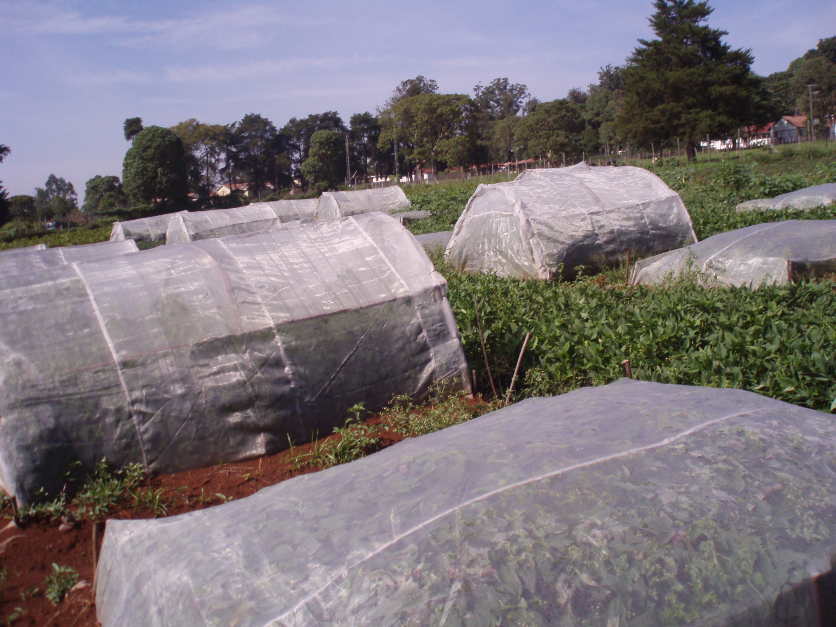
- Variety
Three varieties of sweet potato free from virus but susceptible to SPVD were planted:
V1 Kemb 037 broad leaves and creeping,
V2 Zapallo lobed leaves and erect,
V3 SPK004 lobed leaves and creeping

The trial consisted 3 blocks each with 12 plots of 500 plants, respectively. Each plot consist of 25 lines of 20 cuttings planted in randomized block design (RCBD) spacing was 10cm between plants and 20 cm between rows. Planting date was 29th of June 2009.

Data collection:

Visual virus assessment
Visual virus incidence assessment was done on 50 sample of plants counted along two diagonal lines across each plot, the number of visibly diseased plant will be counted and expressed as a percentage of the total sample ( No. of diseased plants/total sample x100).

ELISA test
Leaf portion (1cm) will be taken from upper middle and lower parts and used for serological test of sweet potato virus with nitrocellulose membrane enzyme linked immunosorbent assay (NCM-ELIZA) as outlined by CIP 2001. Serological test kits containing polyclonal antisera to the sweet potato virus will be used. The kit contained membrane strips pre spotted with virus free sarp (negative control) and sap containing specific virus (positive control). Leave disk will be obtained from the leave harvested from top and middle &bottom of each cutting for NCM-ELISA. Positive and negative reaction will be assessed visually; the degree of purple colour development will be the basis of positive score. Sweet potato specimens that will not react with antisera to any of the tested virus will be grafted into Ipomoea setosa the universal indicator for sweet potato virus and re indexed , characteristic symptom will be noted and leaves of I.setosa assayed by ELISA 4 weeks after grafting

Determination of white fly and aphid populations
Assessment of white fly (Bemisia tabaci) involved direct counting of adult on ventral side of youngest apical leave of the shoot because the adult feed preferentially on the youngest immature leaves. Due to different branching habit of different cultivar the longest shoot was chosen and the total number of adult fly was taken to represent the estimate of whit fly per plant.15 plant were selected at random per plot the assessment was done between 6.00am -8.00am when the white flies are inactive. Similarly aphid population on shoots were examined and counted.
Data analysis
All data collected will be subjected to analysis of variance (ANOVA) using GenStat statistical software; means were separated by Tukey 0.05.

Results

Determination of white fly and aphid population
Both, white fly and aphid were significantly reduced by both fleece cover and fleece tunnel with all varieties at a level of almost no infestation compared to the exposed control. Hence, interaction of variety and treatment was highly significant (p <0.001). However, varieties Kemb 37 and Zapallo had highest white fly populations whereas highest aphid number was found with Kemb 37 comparing the exposed controls, respectively.

Table 1: White fly and aphid populations of three sweetpotato varieties when exposed compared with two fleece- cover technologies (Fleece cover and Fleece Tunnel)

Variety | Treatment | Mean white fly population | Mean aphid population
Kemb 37 | Exposed | 11 a | 16 a
Kemb 37 | Fleece cover | 0.25 c | 0.25 c
Kemb 37 | Fleece tunnel | 0 c | 0.25 c
Zapallo | Exposed | 11.25 a | 4 b
Zapallo | Fleece cover | 0 c | 0.5 c
Zapallo | Fleece tunnel | 0.25 | 0.5 c
SPK 004 | Exposed | 6 b | 1.5 c
SPK 004 | Fleece cover | 0.5 c | 0 c
SPK 004 | Fleece tunnel | 0 c | 0 c
*Different letters indicate significant differences (Tukey p = 0.05)

Determination of virus incidence
Virus incidence was significantly higher in the exposed control than with the fleece cover technologies. However, whereas the direct fleece cover showed no viral infections in the fleece tunnel little viral infections could be identified. Highest virus incidence was found with variety Kemb 37 followed by Zapallo and SPK 004.

Table 2: Number of positive Elisa virus tests (total of 120 samples treatments, respectively) of sweetpotato varieties when exposed compared with two fleece-cover technologies (Fleece cover and Fleece Tunnel)

Variety | Treatment | Virus
Variety | Treatment | SPMMV | SPCSV | SPFMV | SPLV | SPCFV
Kemb 37 | Exposed | 4 | 1 | 2 | 2 | 1
Kemb 37 | Fleece cover | 0 | 0 | 0 | 0 | 0
Kemb 37 | Fleece tunnel | 0 | 0 | 0 | 0 | 1
Zapallo | Exposed | 1 | 1 | 4 | 2 | 2
Zapallo | Fleece cover | 0 | 0 | 0 | 0 | 0
Zapallo | Fleece tunnel | 0 | 0 | 0 | 1 | 0
SPK 004 | Exposed | 2 | 1 | 1 | 0 | 0
SPK 004 | Fleece cover | 0 | 0 | 0 | 0 | 0
SPK 004 | Fleece tunnel | 0 | 0 | 0 | 0 | 0

Discussion and outlook

As this paper is presenting initial results of an ongoing experiment final conclusions cannot be made how effective and sustainable the technologies of fleece covering regarding the conservation of healthy planting stocks are. However, initial results on virus vector white fly and aphid populations as well as the results of the ELISA virus test already reveal a significantly lower vector and virus pressure. Hence, the assumption can be taken that a protection with fleece cover technologies can be a low cost method of maintaining healthy foundation seed over a long period.
Nevertheless, further investigations need to be conducted. The general research question will also be for how long a healthy stock can be conserved - or how many seasons can cuttings from the seed stock be used as healthy planting material. Moreover, the determination of the long term effect on yield of sweetpotatoes in small scale farming system will be done in comparison to their current practice of unprotected vine multiplication.
In summary it can be assumed that cover technologies with horticulture fleece will be an investment with high revenues, due to the maintenance of a healthy sweetpotato vine stock, and thus higher and more stable yields at a relatively low investment cost.

Acknowledgement
This study was financially supported by Core funds of the International Potato Center – Sub Saharan Africa, CIP-SSA, Nairobi, Kenya.
References
Anon.1999.Sweet potato facts, a compendium of key figures and analysis for 33 important sweet potato producing countries. Lima Peru: International Potato Center.
BouwKamp J C, Ngeve JM.1991.Effects of sweet potato virus disease on Genotype in Cameroon. Experimental Agriculture 27:221-225.
Carey EE, Mwanga ROM, Fuentes S, Kasule S, Macharia C, Gichuki ST, Gibson RW, 1998.Sweet potato viruses in Uganda and Kenya: Results of survey. Proceedings of
the sixth Triennial Symposium of the International Society of Tropical root Crops-Africa
Branch (ISTRC-AB),Lilogwe,Malawi,22-28 October 1995,pp.457-461.
Carey EE, Mwanga ROM, Fuentes S, Kasule S, Macharia C, Gichuki ST, Gibson RW, 1998.Sweet potato viruses in Uganda and Kenya: Results of survey. Proceedings of the sixth Triennial Symposium of the International Society of Tropical root Crops-Africa Branch (ISTRC-AB),Lilogwe,Malawi,22-28 October 1995,pp.457-461.
Cohen J, Frank A, Vetten, HJ, Lesemann DE, Loebenstein G, 1992.Purification and properties of closterovirus-like particles associated with white fly transmitted disease of sweet potato. Annals of Applied Biology 121:251-268.
Gibson RW, Mwanga ROM, Kasule S, Mpembe I, Carey EE.1997.Apparent absence of viruses in most symptomless field grown sweet potato in Uganda. Annals of applied Biology 130:481-490.
Gibson Mpembe I,Alicai T,Carey EE,Mwanga ROM,Seal SE,Vetten.Symptom,aetiology and serological analysis of sweet potato virus disease in Uganda. Plant pathol.47; 95102.
Hahn SK, Tery ER 1981 Resistance of sweet potato to virus complex .Hortscience16, 535-7.
Karyeija RF, Gibson RW, Valkonen JPT.1998. The significance of sweet potato feathery mottle virus in subsistence sweet potato production in Africa. Plant disease 82:4-15
Karyeija RF, Kreuze JF, Gibson RW, Valkonen JPT.2000.Synergistic interaction of a potyvirus and a phloem limited crinivirus in sweet potato plants. Virology 269:26-36.
Karyeija RF, Gibson, Valkonen JPT 1998 .The significance of sweet potato feathery mottle virus in subsistence in sweet potato production in Africa. Plant Diseases 82; 4-15.
Ndolo PJ.Carey EE,Gichuki ST,Kamau JW,Maisiba G,Lusweti J,Ngugi,Maina DK.1997.Evaluation of elite sweet potato clones in Kenya. Proceedings of the 4th Triennial Congress of the African Potato Association, pp.94-96.Pretoria, South Africa.
Salazar EL, Fuetes S, Emeka C Ezulike TO, Ogbe F 2001 .Current status of major virus disease of sweet potato. Proceeding of International workshop sweet potato cultivar decline study Exp standard Miyakonojo Japan pp14-19.
Wambugu FM.1991.In vitro and epidemiological studies of sweet potato (ipomoea batatas Lam) virus disease in Kenya. PhD Thesis, University of Bath, 271 pp. transmitted closter virusse. Plant diseases 82; 270-280.

