ClonDiag microarray an efficient tool for parallel detection of sweetpotato viruses.
ClonDiag diagnostic tool will facilitate the sustained availability of quality, disease-free planting material, at required quantities and in a timely fashion.

What is the problem?
Viruses are a major constraint to sweetpotato production, with more than 20 viruses reported. Viral diseases are economically important and impact on research and movement of germplasm across regions. Low virus titers, uneven virus distribution within the plant, presence of inhibitors, the occurrence of mixed infections, diverse viral strains; make diagnosis of sweetpotato viruses difficult. Current Nitrocellulose membrane ELISA diagnostic tests are not sensitive enough to reliably detect viruses directly from sweetpotato On the other hand, available molecular tests require expensive laboratory equipment to perform and a high level of experience.

What do we want to achieve?

The current phytosanitary screening/cleaning process requires the introduction of plant material into tissue culture followed by screening for more than ten viruses. The plants under go two testing regimes; with each round of virus testing taking six months to a year or even more to verify if it is virus-free. Greenhouse grafting to host plants to confirm the health status make the current process lengthy. We aim at having a test that can significantly reduce this time. In addition, the test should detect the more than ten sweetpotato viruses at one go.

Where are we working?

We are validating the improved ClonDiag diagnostic tool to evaluate if it can replace the NCM-ELISA and grafting segment.

How are we going to make it happen?

Fourth improved iteration array delivered and interlab testing conducted between CIP Lima and CIP Nairobi. Twenty five samples previously tested with NCM ELISA were identified and sub samples exchanged with Lima. Parallel test were conducted in Lima and Nairobi, to ensure that the test meets the criteria of sensitivity, specificity, repeatability and accuracy.

What have we achieved so far?

- The present ClonDiag microarray is able to simultaneously detect all the ten viruses detected by NCM ELISA with an additional five viruses detected.
- Time to results for grafting/NCM ELISA is 6-12 months while ClonDiag is two days
- ClonDiag costs USD 70 per sample and detects up to 21 viruses while grafting/NCM ELISA costs USD 130 to test 10 viruses per sample.
- The test has the capability of differentiating different virus strains i.e. Eastern and Western Africa strains of Sweetpotato chlorotic stunt virus.
- Highest concordance between NCM and ClonDiag test.
- Sensitivity of the ClonDiag test is more than to that of NCM.
- ClonDiag test proved to be suitable for routine diagnosis of sweetpotato viruses.

What’s next?

Confirm all viruses detected in samples by Next Generation Sequencing. Based on results access discrepancies in probes and recommend for improvement.

List of partners, full name plus acronym in parentheses

- International Potato Centre (CIP) – Lima
- International Potato Centre (CIP) – Nairobi
- Food Environment Research Agency (FERA) - UK

Two Key Contact Persons and their email addresses

- Dr. Jan Kreuze (J.KEREUZE@CGIAR.ORG)
- Bramwel W Wanjala (B.WANJALA@CGIAR.ORG)

Please include 4 relevant photos of high resolution (at least 1 MB) with captions and the credit for the photographer.

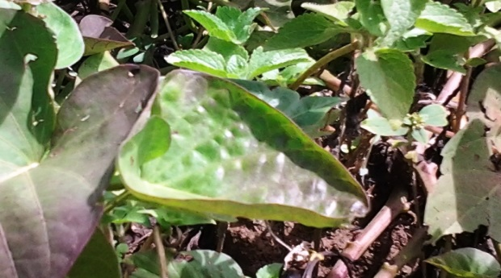
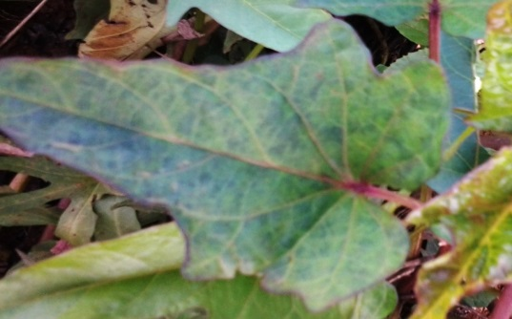
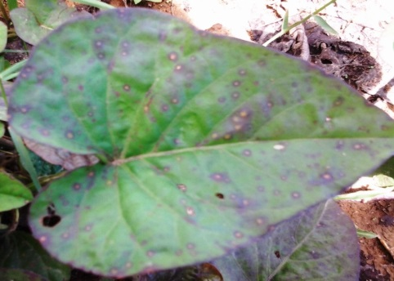

B
A
C
D

Figure 1: Different symptom expression in sweetpotato varieties: A – purple rings, B – Roll up, C – mottling and D – chlorosis and vein clearing. Photo credit: Bramwel Wanjala
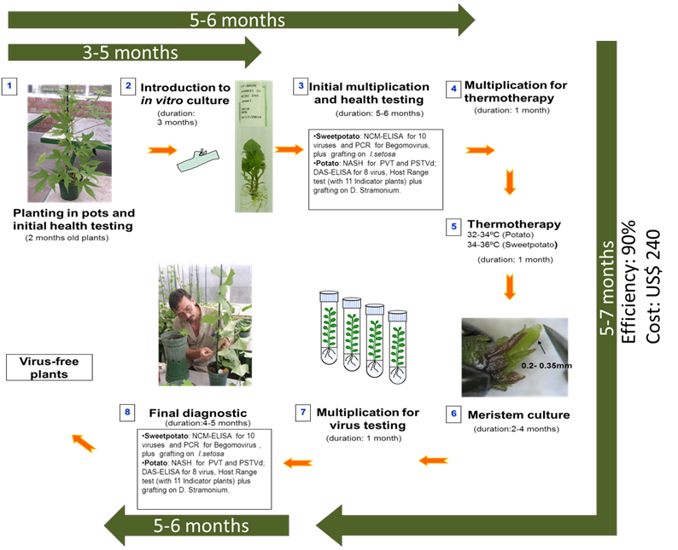
Figure 2: Steps and timelines for virus clean up and testing by conventional grafting onto Ipomoea setosa and NCM ELISA method. Virus clean-up process and current testing by grafting onto Ipomoea setosa and NCM ELISA method takes upto 12 months.
Photo credit: Jan Kreuze
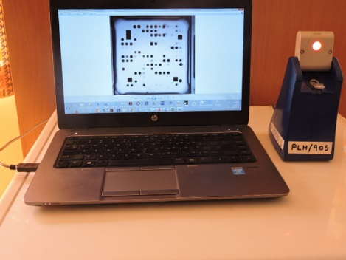
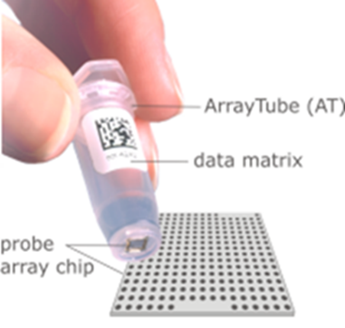
A
B

Figure 3: Microarray tube with 21 probes on array chip (A) and Array tube reader connected onto a computer analyzing virus spots (B)

Figure 4: Parallel detection capability of ClonDiag. Thirteen of the twenty one viruses detected in single run.

