Review on Staple Based Nutritious Food Product Development from Orange Fleshed Sweet Potato (Impomia batatas L. Lam) in Ethiopia

Kebede Abegaz (Dr), School of Nutrition, Food Science & Technology, Hawassa University, Ethiopia

Background
There is a need to shift from subsidized periodic capsule distribution to sustainable food-based intervention through nutrition-sensitive agriculture (NSA) to diversify diets and tackle malnutrition. Orange flesh sweet potato (OFSP) is naturally Biofortified, rich in β-carotene as precursor of vitamin A (VA), easy to grow and affordable to resource poor consumers. The OFSP is rich in vitamins (vitamins A, B2, B3, B6 and C), minerals (Fe, Zn, K and Cu), dietary fiber and antioxidants, such as phenolic acids, anthocyanins, tocopherol and make it a promising affordable alternative for healthier food diversity. Thus, NSA-based vitamin A (VA) enrichment of staple foods using OFSP and appropriate technology is recommended to reduce VA deficiencies in children and women in child bearing age.

The findings on food product development from cereal based staple foods enriched with OFSP showed high potential as source of pro-VA.

Figure 2: Addition of OFSP and legume to enrich cereal based staple foods with vitamin A, protein and minerals
Legumes (Protein)
Other Ingredients
OFSP
(Vit. A)
Cereal Staples
Food Safety & Hygiene
Proper Food Tech-nology
Nutritious Food
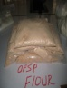

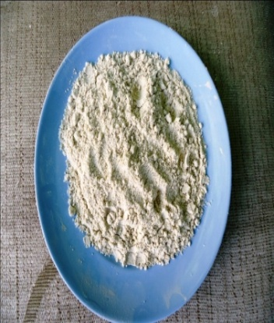

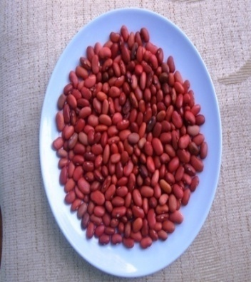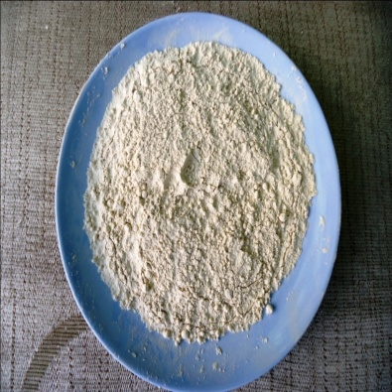

Cereal staple-based food products nutritionally enriched with VA, protein and minerals were made from composite flour of cereals, OFSP and legumes as shown below (Table 1). It illustrated the potential of OFSP for NSA and food approach nutrition intervention.

Table 1 Improvement of cereal staple based food products in vitamin A contents with addition of OFSP powder
Staple* | Range of Addition |  | Type of Food | Target population | Amount of VA | Remark
 | OFSP | Legume**
Quality protein maize (36%), Red teff (10%) | 18% | 36% Chickpea | CF, porridge | Children  6-23 month | ß-carotene = 565.09+4.41 (μg RE)*** | Biofortified, soaked & germinated cereals & legumes increased minerals
Wheat | 10-30% | Fenugreek | Fermented flat bread | Pre-school children | 30% OFSP flour: 1924 ± 0.07(µg RE); 83.3% RDI**** to 3 yrs of age and  74.2% RDI to 4-6 yrs old children
Maize | 25- 35% | 25% bean | CF, porridge | Children  6-23 month | VA density (µg RAE/ 100 Kcal) = 85.52  100 Kcal serving of porridge provides 21.31% of the DRI
Wheat | 30% | X | Biscuits | School children | Baked: 200°C/12 min = 6.01 ± 0.00 (μg/g), 220°C for 12 min  = 5.55 ± 0.01(μg/g) | Dry/ long cooking reduced vitamin A in biscuits
Sorghum | 25-35% | X | Flat bread | Pre-school children | Vit A = 694.75(µg RAE/100 gm
Maize | 25-35% | X | Flat bread | Lactating women | Vit A = 269.63 (µg RAE/100 gm = 21% RDI
* = Soaking and germination of these cereals reduced tannins & phytate, but all of them showed zero content of vitamin A in the absence of OFSP.
** = Addition of legumes improved protein, zinc, iron & nutrient density (data not shown); *** RE = Retinol equivalent; **** RDI = required daily intake.

Conclusion
Addition of OFSP powder and legumes improved vitamin A, protein & minerals (iron, zinc) contents of cereal based staple foods with high consumer acceptance. Biofortified crops, soaking and germination of cereals and legumes reduced anti-nutrients (phytate & tannins) and improve bioavailability of these foods (in molar ratio).

Recommendation
Incorporation of OFSP & legumes in staples using proper cooking methods and promotion on them are recommended as food based intervention approach to reduce malnutrition in Ethiopia.

